Photo OCR Machine Learning Problem

# Problem Description and pipeline

Photo OCR – Photo optical character recognition

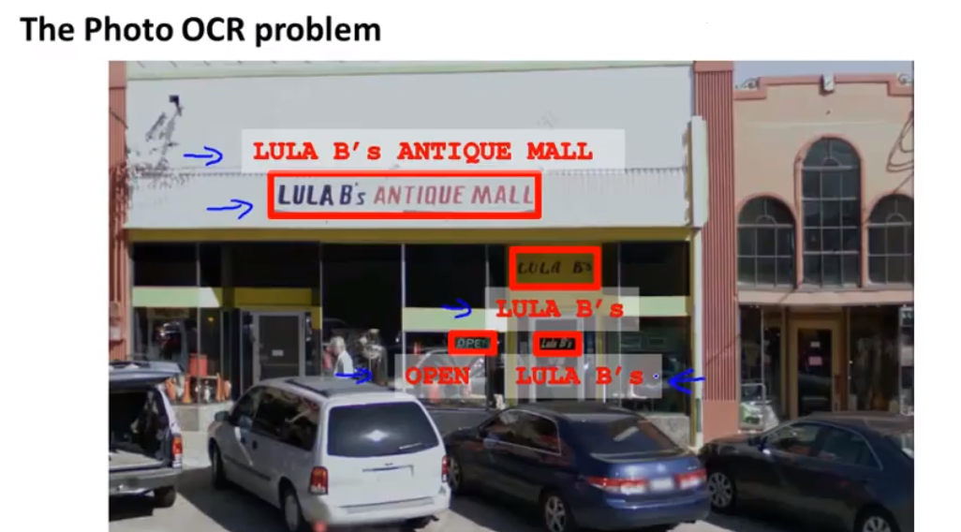

This problem can be divided into various steps commonly known as pipeline which can have following stages.

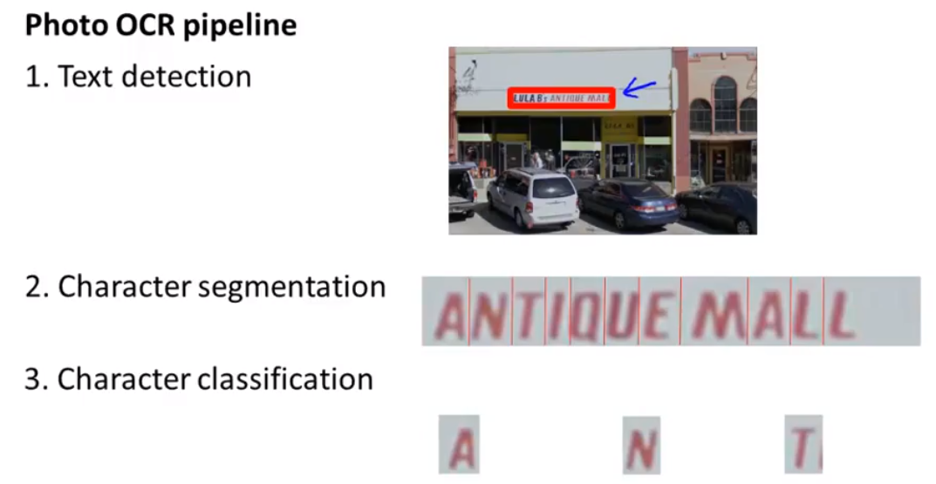

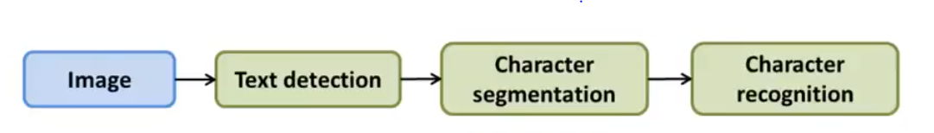

# Sliding Windows